ASSIGNMENT-3
TIME SERIES DATA
-RAJU RISHIKESH GOLLAPALLY
-SAI SHARANYA DEVAMBATLA

By using MSE loss function, Mean Absolute Error (MAE) metric and report optimizer we learnt about different methodologies which have the impact on performance of the models.
Here, we used MAE over accuracy as MAE is the better statistic than Accuracy for temperature prediction as the goal here is to predict continuous numerical values.

Model | Dense Units | Dropout | Loss | Test MAE
A Simple Machine Learning model | 16 | No | 11.1117 | 2.63
A simple Machine Learning model | 64 | No | 11.6629 | 2.69
A Basic Machine Learning model | 8 | No | 11.7294 | 2.66
A Basic Machine Learning model | 32 | No | 11.2241 | 2.64
An 1D Convolution model | 16 | No | 16.2741 | 3.20
RNN models (Recurrent baseline)
LSTM layers | 16 | No | 10.3632 | 2.53
LSTM layers | 16 | Yes | 10.8095 | 2.58
GRU (later replaced with LSTM)- not needed but did for comparison | 16 | Yes | 9.9159 | 2.45
Bidirectional architecture model | 16 | No | 11.1938 | 2.65
Combination of 1d_Convent and LSTM model with dropout
Combination | 16 | Yes | 11.4442 | 2.66

Summary:
- It is not always the case that improved performance results from having more dense units in the hidden layers. A model's accuracy can occasionally be improved by adding less units.
- The optimal Test MAE for the basic machine learning model is found in both 16 and 32 when it is tested with various dense units of 8, 16, 32, and 64. The 1D Convolution model and various RNN models (LSTM layer, GRU, and Bidirectional architecture model) have been evaluated for testing the Test MAE and loss function using Dense Unit 16.

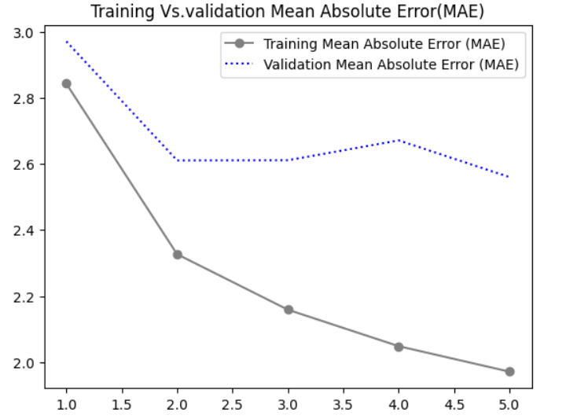

- There is minimal difference between the other setups, with configuration 16 achieving the best MAE of 2.69 with a loss of 11.6629.
- The least loss function (9.9159) and best MAE (2.45) of any combination tested, except GRU, are found in the LSTM model with dropout (0.5).

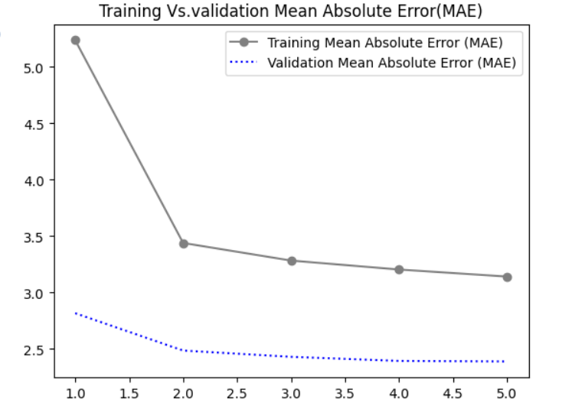

- The LSTM model with dropout (0.5) and 1d_convents have been coupled since their MAE is the best. With an MAE of 2.57, and a loss function of 10.8095, the combination produced the best MAE of all the models.

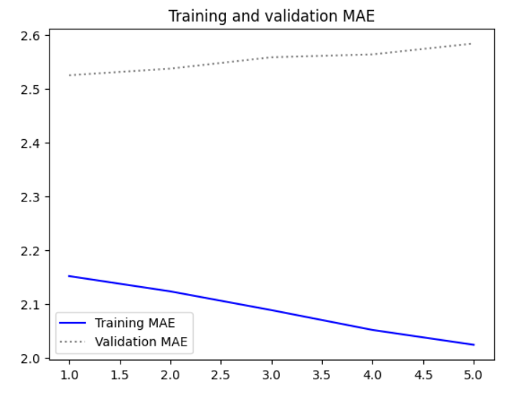

Recommendations:
- The Mean Absolute Error, or MAE, is a useful technique for working with time-series data. It is especially useful when estimating continuous numerical values like temperature.
- Overfitting may be avoided by employing dropouts, as seen by the LSTM model with dropout achieving a lower MAE and loss.
- The 1D Convolution model's MAE is higher than the MAEs of a few RNN models, indicating that RNNs could match the given time-series data more closely.
- The best MAE of 2.66 and a reduced loss function of 11.4442 are obtained when combining LSTM with dropout and 1D Convolution layers, indicating that this hybrid technique is a promising contender for temperature prediction.
- A consistent gain in performance is not obtained by increasing the number of dense units in the hidden layers. Higher precision can occasionally be attained by models with fewer units. The trade-off between model complexity and performance must be considered to get at equilibrium.

In addition, to be built-in the LSTM model with dropout and deep insights into mixing architectural nets, such as LSTM with 1D Convolution, should be developed. Also, MAE (mean absolute error) is a better indicator than accuracy for the classwork due to how the task is designed. More accurate temperature prediction models may be achieved after other experiments and further optimization.

